Master Functional Document

Application | NGERP - Centra
Service Bundle | Master Management
Service Request | Manage Item List

Description :

Manage Item list is to categorise partners as global category.

Workflow Process :

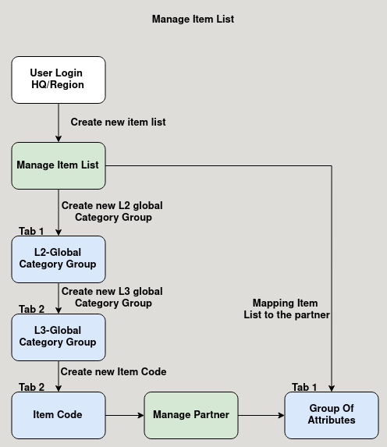

Business Rules :

- user can login as HQ or Region to create a new item list.
- The item list is used to categorise the partner as L1, L2, L3 global category.
- This item list is mapped in the manage partner master group of attributes tab.

